1️⃣ Introduction to Optimization
🔹 What is Optimization?
In Machine Learning, optimization means:
Finding the best model parameters (weights & biases) that minimize the error (loss function).
Mathematically:
$$θ^{*}=arg⁡\underset{θ}{min⁡}L(θ)$$
Where:
- $θ$= model parameters (weights, bias)
- $L(θ)$= loss function
- Goal = minimize loss

🔹 Why Optimization is Needed?
When training a neural network:
- We make predictions.
- Compute error using loss function.
- Adjust weights to reduce error.
- Repeat until minimum loss is reached.
This adjustment process is called optimization.

🔹 Common Loss Functions
🔸 Mean Squared Error (MSE) – Regression
$$MSE=\frac{1}{n}∑(y-\hat{y})^{2}$$
🔸 Cross Entropy – Classification
$$L=-∑ylog⁡(\hat{y})$$

2️⃣ Gradient Descent (GD)
🔹 What is Gradient Descent?
Gradient Descent is an algorithm used to minimize the loss function.
It updates weights in the opposite direction of gradient.
$$w=w-η\frac{∂L}{∂w}$$
Where:
- $η$= learning rate
- $\frac{∂L}{∂w}$= gradient

🔹 Why Opposite Direction?
Gradient points toward maximum increase.
We move in opposite direction to reach minimum loss.
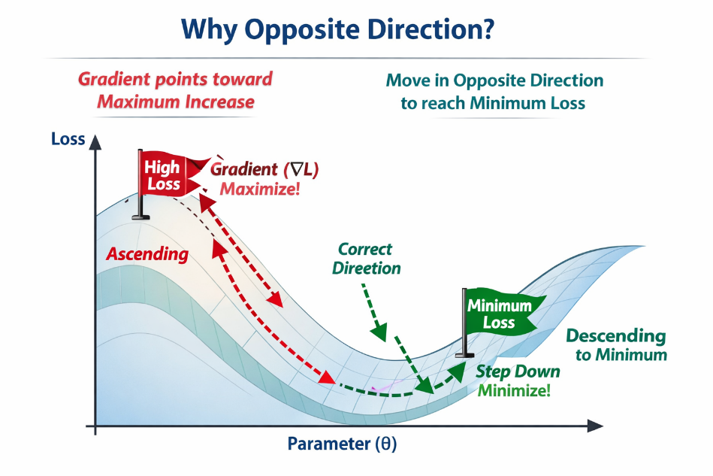

🔹 Types of Gradient Descent
1️⃣ Batch Gradient Descent
- Uses entire dataset
- Stable
- Slow for large datasets
2️⃣ Stochastic Gradient Descent (SGD)
- Uses 1 data point at a time
- Faster
- Noisy updates
3️⃣ Mini-batch Gradient Descent
- Uses small batch (32, 64, 128)
- Most commonly used

3️⃣ Stochastic Gradient Descent (SGD)
🔹 Update Rule
$$w=w-η∇L(w;x_{i})$$
Where:
- Update after each training sample

🔹 Why SGD is Powerful?
✅ Faster convergence
✅ Escapes local minima
✅ Good for large datasets

🔹 Problem with SGD
- Noisy updates
- Fluctuates around minimum
- May not converge smoothly

4️⃣ Challenges in Optimization
Optimization in Deep Learning is NOT easy.

🔹 1️⃣ Local Minima
Model may get stuck in local minimum instead of global minimum.
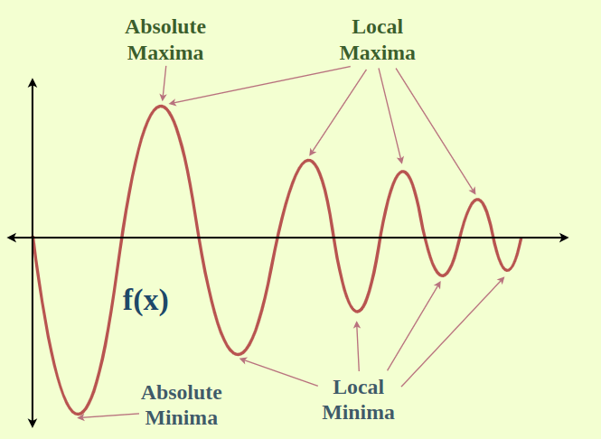
🔴 Why Is Getting Stuck in a Local Minimum a Problem?
🔹 First, Understand the Difference
- Global Minimum → Lowest possible loss in the entire loss surface
- Local Minimum → Lowest loss in a small region, but NOT the lowest overall
Think of it like hills and valleys:
You want to reach the deepest valley (global minimum)
But you might stop in a small shallow valley (local minimum).

🚨 Why Is This a Problem?
- Model Performance Is Not Optimal
If stuck in a local minimum:
- Loss is higher than it could be
- Accuracy is lower than possible
- Model predictions are not best
So your model is suboptimal.

- Poor Generalization
A bad local minimum may:
- Fit training data poorly
- Perform worse on test data
- Reduce model reliability

- Wasted Training Potential
You trained the model for many epochs,
but it didn’t reach the best solution.
That means:
- More computation wasted
- More training time
- No best results

- Can Block Learning Progress
At a local minimum:
$$∇L=0$$
Gradient becomes zero.
Since Gradient Descent updates using:
$$w=w-η∇L$$
If gradient = 0 → weights stop updating.
Model thinks it has “finished learning”.
But it hasn’t reached the best solution.

🔹 2️⃣ Saddle Points
Gradient = 0 but not minimum
Very common in high-dimensional networks.
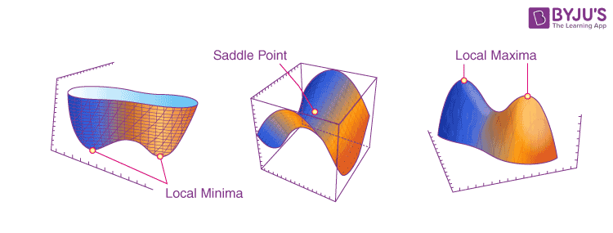
What Is a Saddle Point?
A saddle point is a point on the loss surface where:
$$∇L=0$$
(gradient is zero)
BUT ❌ it is not a minimum
AND ❌ it is not a maximum.

📌 Why is it called “Saddle”?
Because it looks like a horse saddle:
- Curved upward in one direction
- Curved downward in another direction
Like this:
- Along x-direction → looks like a minimum
- Along y-direction → looks like a maximum
So overall → it is neither.

🔍 Mathematically
At a saddle point:
- First derivative (gradient) = 0
- Second derivative has mixed signs
Example function:
$$f(x,y)=x^{2}-y^{2}$$
At (0,0):
- Gradient = 0
- But not minimum or maximum

🚨 Why Are Saddle Points a Problem?
Because Gradient Descent checks:
$$∇L=0$$
If gradient is zero → it thinks training is done.
But actually:
- You are stuck on a flat unstable region.
- It’s not the lowest point.

🔷 Why Are Saddle Points More Common in Deep Learning?
Deep neural networks have:
- Thousands or millions of parameters
- Very high-dimensional loss surfaces
In high dimensions:
- True local minima are rare
- Saddle points become very common
This is a mathematical property of high-dimensional spaces.
So modern research shows:
👉 Deep networks suffer more from saddle points
👉 Not from bad local minima

🔹 3️⃣ Vanishing Gradient Problem
- Gradients become extremely small.
- Happens in deep networks.
- Weights stop updating.
Common with:
- Sigmoid
- Tanh

🔹 4️⃣ Exploding Gradient Problem
- Gradients become very large.
- Causes unstable training.
- Loss becomes NaN.
Common in:
- RNNs

🔹 5️⃣ Poor Learning Rate
Too small → slow learning
Too large → divergence

🔹 6️⃣ Overfitting
Model memorizes training data but fails on test data.

5️⃣ Hyperparameter Tuning
Hyperparameters are NOT learned automatically.
They must be chosen carefully.

🔹 1️⃣ Learning Rate (η) (eta).
What is it?
Step size in gradient descent.
$$w=w-η∇L$$
- So, the gradient is basically a direction and a size. It tells you how much the loss would change if you nudge the weights slightly in a certain direction. The learning rate, on the other hand, is like a scaling factor. Once you know how steep the slope is (the gradient), you multiply it by the learning rate to decide how big a step to take. In short: the gradient says, "Here's the direction and strength," and the learning rate says, "Scale that step so we don't overshoot or undershoot."

- Overshooting means you take a step that’s too big, so you jump past the minimum and end up with higher loss. Undershooting means your step is too small, so you barely move toward the minimum, making learning very slow.

If Learning Rate is:
🔸 Too Small
- Slow training
- May get stuck
🔸 Too Large
- Overshoots minimum
- Loss oscillates
- May diverge

Best Practices
- Start with 0.01 or 0.001
- Use learning rate scheduler
- Use adaptive optimizers (Adam)

Popular Optimizers
- SGD
- Momentum
- RMSprop
- Adam
Adam combines:
- Momentum
- Adaptive learning rate

🔹 2️⃣ Batch Size
What is Batch Size?
Number of samples used before updating weights.

Types
- 1 → SGD
- Full dataset → Batch GD
- 32/64/128 → Mini-batch

Effect of Batch Size
Small Batch | Large Batch
Noisy | Stable
Better generalization | May overfit
Slower per epoch | Faster per epoch

Ideal Batch Size
- 32 or 64 commonly used
- Depends on memory and dataset

🔹 3️⃣ Dropout
What is Dropout?
A regularization technique that randomly disables neurons during training.
Example:
If dropout = 0.5
50% neurons are randomly turned off.

Regularization is all about controlling the complexity of your model so it doesn't memorize the training data too tightly. When you use dropout, you're randomly turning off neurons during training, which stops any one neuron (or feature) from dominating the model. So, instead of relying on just a few features, the model has to learn a more balanced set of relationships.

Why Dropout?
Prevents overfitting.
Forces network to:
- Not rely on specific neurons
- Learn robust features

During Training
Random neurons dropped.
During Testing
All neurons active (scaled appropriately).

Typical Values
- 0.2 → Input layer
- 0.5 → Hidden layers
- So, the idea is that in the input layer, you don't want to drop too many neurons because you still want all the raw input information to get through. If you drop out too much at the input, you might lose critical data too early. But in the hidden layers, the model has already extracted some features, so by dropping about 0.5, it really prevents overfitting, as the network can’t rely on a few features too much. It’s kind of a sweet spot: 0.2 at input keeps the raw signal strong, and 0.5 at hidden layers gives the model enough flexibility to not overfit.

6️⃣ How All These Work Together
During training:
- Choose learning rate
- Choose batch size
- Use optimizer (SGD/Adam)
- Apply dropout to prevent overfitting
- Monitor validation loss

7️⃣ Interview-Level Conceptual Differences
GD vs SGD
Feature | GD | SGD
Speed | Slow | Fast
Stability | Stable | Noisy
Dataset Size | Small | Large
Escapes Local Minima | No | Yes

Learning Rate vs Batch Size
- Learning rate → controls step size
- Batch size → controls noise in gradient

8️⃣ Advanced Optimization Techniques (Bonus for Interviews)
- Learning Rate Scheduling
- Early Stopping
- Gradient Clipping
- Batch Normalization
- Adaptive Optimizers (Adam)

9️⃣ Simple Real-World Analogy
Imagine you are descending a hill blindfolded:
- Gradient = slope direction
- Learning rate = step size
- Batch size = how much terrain info you collect before stepping
- Dropout = forcing you to use different senses so you don’t depend only on one

🔟 Summary
Optimization = minimize loss
Gradient Descent = basic algorithm
SGD = faster, noisy updates
Challenges = local minima, vanishing gradient, etc
Hyperparameters = learning rate, batch size, dropout

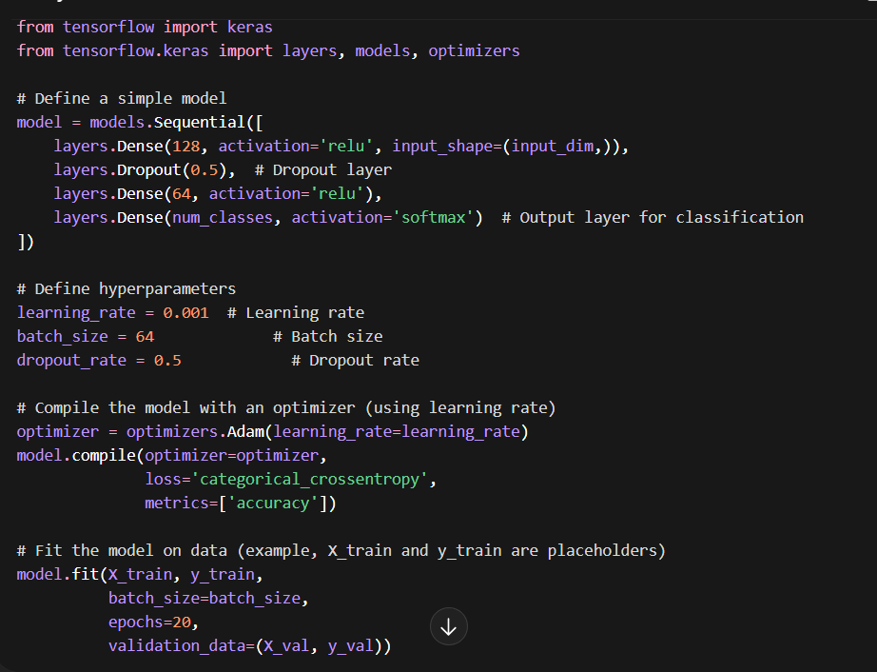
• The learning rate is set to 0.001 (for the Adam optimizer).
• The batch size is 64 (so each update uses 64 samples).
• Dropout is applied at 0.5, meaning half the neurons are randomly turned off during training.

